For the stand - up Boater
Sea Knees
It Takes the Motion out of the Ocean

Sea Knees Sea trial in a 27 ft. Center Console

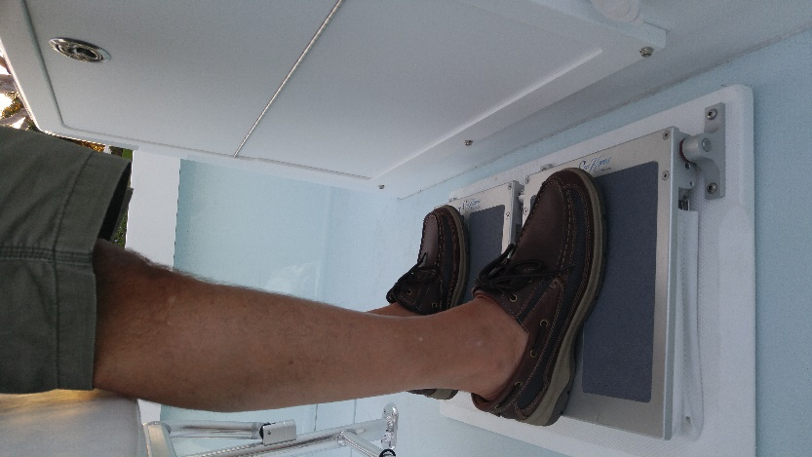

The Sea Trial took place on 2/15/2017 off shore from the St. Lucie inlet.

The seas were 3 to 5 ft. with short durations. The winds around 13 mph.
Boat speeds were around 30 knots.

Both the Mate and the Captain were fitted with 3 axis G force measuring devices.
The attached chart shows the Vector Sums of the 3 axis’s for each.

Please see G force chart attached

A video is available on YouTube at “Sea Knees Sea Trial”

Sea Knees is Trade Marked and Patent Pending device for the Stand-Up Boater.
If interested in improving the ride of your Boat, please feel free to contact me, Paul Nowack at
(847) 867-3901 or email me at <pauln@nowacksales.com>

